Sunhillo Technical Support Frequently Asked Questions

Sunhillo Technical Support Frequently Asked Questions

SUN9247, Revision 1.3• December 16, 2020
©2020 Sunhillo Corporation
444 Kelley Drive
West Berlin, NJ 08091-9210
www.sunhillo.com
Phone 856.767.7676 • Fax 856.767.9557

Contents
FAQ 1: On my RICI/Longport/Ventnor/SGP/Brigantine/ Margate SureLine Web Interface, when I create a dataflow, and click Save File or Save File As, I get this error on the Web GUI: Signal 11 last debug line 0 aborting. How come? 1
FAQ 2: I Created an Account, But I Never Received an Email to Setup My Password. How Come? 3
FAQ 3: Where Can I Find the Documentation for my Sunhillo Product? 4
FAQ 4: How Do I Register My Sunhillo Product on The Support Portal? 5
FAQ 5: I Registered my Sunhillo Product, But Its Warranty Status Says Out of Warranty, And I Cannot Access Any Downloadable Content Such as The Latest Software, Plugins Or Operating System Releases. Why Not? 7
FAQ 6: Where Can I Find the Software, Plugins, Or Operating System Download Links for Updates to my In-Warranty/Maintenance Sunhillo Product? 8
FAQ 7: How would I know when a new release is available on the Sunhillo Support Portal for download for my Sunhillo product? 9
FAQ 8: I Need to Upload Files to Sunhillo. Is There A Place on My Support Portal Account Where I Can Do That? 10
FAQ 9: I Need to Download Files from Sunhillo on my Support Portal. Is There A Place on my Support Portal Account Where I Can Do That? 11
FAQ 10: Where Can I Find the Pinout Diagram for my Sunhillo Product’s Serial Ports? 12
FAQ 11: What Serial Protocols and Radar Conversions Are Supported on Sunhillo SureLine Products? 13
FAQ 12: What Is the Difference Between a Longport STARS Ethernet Switch Module and A Longport COTS Ethernet Switch Module? 14
FAQ 13: Should I Log into The Eth5 Maintenance Port on The Front of The Longport Ethernet Switch Module for Configuration or Connect It to Live Data Connections? 15
FAQ 14: What Type of Antenna Cable Is Best to Use with Sunhillo’s ADS-B Receiver Products? (Margate II Or Longport ADS-B Receiver) 16
FAQ 15: I Cannot Access the Web GUI Of My RICI/Longport/Ventnor/ Brigantine/Margate And Don’t Know Its Network Settings or IP Address. How Do I Perform A Factory Reset to Log In? 17
FAQ 16: Where Do I Get the FTDI Drivers for The Console Cable for Connecting to Sunhillo Products Such as RICI4500s, RICI5000s, Longport Pcms, Ventnors, Brigantines, Margate I M4I, And the Margate II ADS-B Receiver? 18
FAQ 17: How Do I Know What Operating System And What Software Releases Go Together and How to Upgrade to The Next SureLine Operating System To Use the Latest Software? 19
FAQ 18: How Does Sunhillo’s SureLine Single Sensor Tracker and Multi-Track Fuser Package Work? 21
FAQ 19: How Do I Know What All the SureLine Dataflow Configuration Parameters Do Since They Are Not All in The SUN2353 - SureLine User’s Guide? 23

FAQ 1: On my RICI/Longport/Ventnor/SGP/Brigantine/ Margate SureLine Web Interface, when I create a dataflow, and click Save File or Save File As, I get this error on the Web GUI: Signal 11 last debug line 0 aborting. How come?
Answer:

Sunhillo’s SureLine software that runs on many of our products is compatible with Mozilla Firefox versions 45 thru 67 and Internet Explorer 11 for Windows 7 thru Windows 10. Recent Google Chrome and Mozilla Firefox updates have caused an incompatibility with our COTS and SureLine software’s Web Interface that causes many issues with our dataflow configuration functionality and with editing and saving the configuration file. Using any unsupported web browsers to create and save configurations could result in a corrupted configuration files that may be unrecoverable by normal methods without contacting Sunhillo technical support.

SureLine release 7.6.1 for applicable Sunhillo SureLine products has corrected this issue for support on the latest Mozilla Firefox versions. If you encounter this error when editing or saving your configuration on a Sunhillo product running the SureLine Web Interface or other products running a legacy Sunhillo Web Interface, please try using the following web browsers on Windows 7 or Windows 10 for best results: Mozilla Firefox version 45 thru 67 or Internet Explorer 11. There is a field bulletin that includes more information on this Sunhillo Web Interface compatibility issue and is available on your support account under Downloads and Uploads Documentation 2-Sunhillo Field Bulletins Sunhillo Web GUI Browser Compatibility Issue.pdf
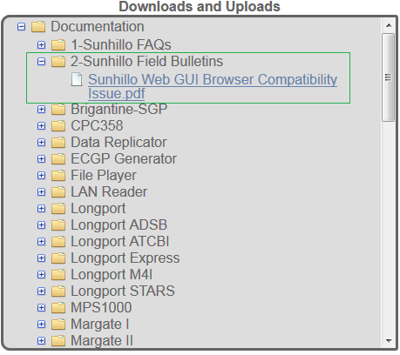

FAQ 2: I Created an Account, But I Never Received an Email to Setup My Password. How Come?
Answer:

Some email servers may block our Support Portal’s automated password registration email from password@sunhillo.com, or it may end up as junk mail or spam. If you do not receive the email in a timely fashion, please contact support@sunhillo.com and we will manually resend the link to setup your account password as soon as possible.

FAQ 3: Where Can I Find the Documentation for my Sunhillo Product?
Answer:
1. Go to https://support.sunhillo.com
2. Create an account or login if you already have an account
3. Once logged in, under Downloads and Uploads, there is a Documentation folder and within it is a list of products. Inside each folder is the applicable documentation for each product. Inside each folder are links to all documentation corresponding to that product.
4. Click the appropriate link to download the documentation you need.
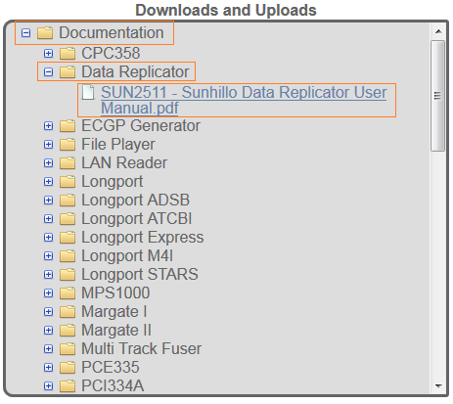

FAQ 4: How Do I Register My Sunhillo Product on The Support Portal?
Answer:
1. Go to https://support.sunhillo.com
2. Create an account or login if you already have an account
3. Register one of the following products by entering its serial number in this textbox:
a. The product serial number can be found on the About page of the Web GUI for SureLine products
b. Most, but not all, Sunhillo products can be registered through the Support Portal.

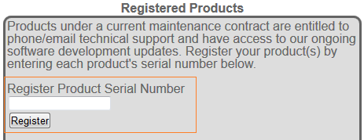

c. The products that can be registered on the Support Portal by serial number entry are the following:
- RICI4500
- RICI5000
- RICI 4500 (Mode 4 Interrogator)
- Longport Processor Card Module (STARS)
- Longport Processor Card Module (ATCBI)
- Longport Processor Card Module (COTS/SureLine)
- Longport Processor Card Module (Mode 4 Interrogator)
- Longport Express
- Ventnor
- Margate II ADS-B Receiver
- Surveillance Gateway Processor (SGP)
- Surveillance Data Replicator (SDR)
- Brigantine-SGP
- Data Replicator
- Margate I
d. For support for any other Sunhillo products not on this list, email support@sunhillo.com and someone will be happy to assist you with whatever you need.

FAQ 5: I Registered my Sunhillo Product, But Its Warranty Status Says Out of Warranty, And I Cannot Access Any Downloadable Content Such as The Latest Software, Plugins Or Operating System Releases. Why Not?
Answer:

You must have an active warranty or maintenance contract on all your products in order to access downloadable content such as software updates and operating system updates. You can see your warranty/maintenance status under the Registered Products area in the Warranty Status column. For extended maintenance on all your Sunhillo products, please contact sales@sunhillo.com

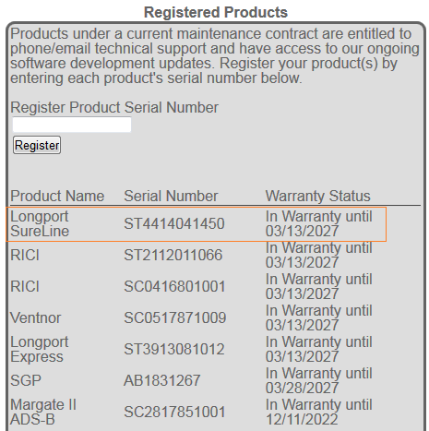

FAQ 6: Where Can I Find the Software, Plugins, Or Operating System Download Links for Updates to my In-Warranty/Maintenance Sunhillo Product?
Answer:

1. Go to https://support.sunhillo.com
2. Create an account or login if you already have an account
3. Once logged in, under Downloads and Uploads, there is a list of Sunhillo products as folders. Inside each folder is the applicable download link(s) for each product.
4. Click the appropriate link to download the software you need.
5. MD5 checksum files are available for all software and operating systems for further download verification post-download from our support portal.
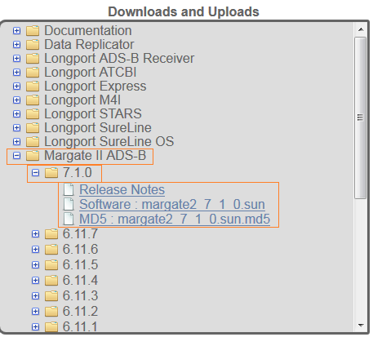

FAQ 7: How would I know when a new release is available on the Sunhillo Support Portal for download for my Sunhillo product?
Answer:

1. Go to https://support.sunhillo.com
2. Create an account or login if you already have an account
3. Once logged in, under Email Notifications, there is a list of products with checkboxes. Select those products you wish to receive email notifications about.
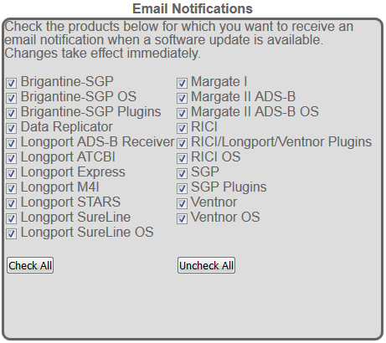
4. Look for emails from webmaster@sunhillo.com about new releases available on the Sunhillo Support Portal for download.
5. If you have a product not listed and would like information about it, please contact support@sunhillo.com

FAQ 8: I Need to Upload Files to Sunhillo. Is There A Place on My Support Portal Account Where I Can Do That?
Answer:

Yes, there is. Under Downloads and Uploads, there is a folder titled “Customer Uploads” where you can upload files up to 10 mb by default. If you need more space, please contact support@sunhillo.com and we can increase your account’s upload area quota as needed.
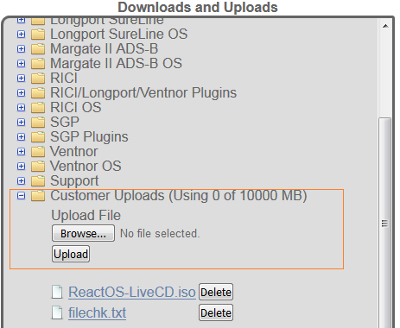

FAQ 9: I Need to Download Files from Sunhillo on my Support Portal. Is There A Place on my Support Portal Account Where I Can Do That?
Answer:

Yes, there is. Under Downloads and Uploads, there is a folder titled “Support” where you can download files, we have placed there for you. You should receive email notifications when Sunhillo’s support staff has provided you files in your Support folder.
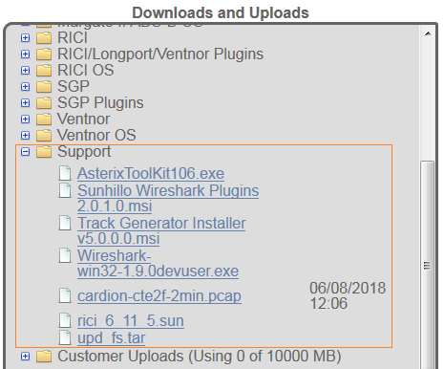

FAQ 10: Where Can I Find the Pinout Diagram for my Sunhillo Product’s Serial Ports?
Answer:
Each product’s specific pinout diagram is in the product’s hardware user’s guide which is available for download on the Support Portal and is also in SUN2353 - SureLine User’s Guide.pdf. Create an account, login, and download the hardware and/or SureLine user’s guide to find the pinout diagram for your Sunhillo product.

FAQ 11: What Serial Protocols and Radar Conversions Are Supported on Sunhillo SureLine Products?
Answers:

The specific serial protocols supported on RICI/Longport/Ventnor SureLine are shown below. For more information on how these work with Sunhillo products, please reference SUN2353 - SureLine User’s Guide.pdf or contact support@sunhillo.com
SureLine Serial Protocols
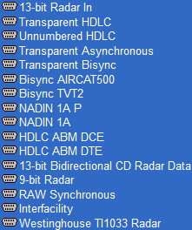
The SureLine product datasheet contains a conversion chart found on our main website which summarizes the radar conversions supported on SureLine products. Sunhillo is continually adding conversion support and offers custom conversions as an offering. For more information on custom conversions, please contact support@sunhillo.com
Here is a link to the SureLine Software Product Datasheet on Sunhillo’s website:
SureLine Datasheet

FAQ 12: What Is the Difference Between a Longport STARS Ethernet Switch Module and A Longport COTS Ethernet Switch Module?
Answer:

A Longport STARS Ethernet switch module has a single VLAN across all 4 Ethernet ports that map to eth0 only. This switch is meant to be used with Longport STARS processor card modules only; a Longport COTS Ethernet switch module has 2 VLANS where the top 2 physical ports map to the eth0 LAN and the bottom 2 physical ports map to the eth1 LAN. This switch configuration is meant to be used with Longport ATCBI/COTS/SureLine processor card modules only. It should also be noted that the switch configuration can only be changed at Sunhillo’s factory, and not in the field.

FAQ 13: Should I Log into The Eth5 Maintenance Port on The Front of The Longport Ethernet Switch Module for Configuration or Connect It to Live Data Connections?
Answer:
No, you should not use it to configure or for live data connections. It is a spanning port and its only reliable purpose is for network monitoring of the Longport switch via Wireshark. It should not be relied on for individual PCM Web GUI access, or for live data connections. Do not connect this eth5 maintenance port to your routers/switches/hubs for permanent field use cases!

FAQ 14: What Type of Antenna Cable Is Best to Use with Sunhillo’s ADS-B Receiver Products? (Margate II Or Longport ADS-B Receiver)
Answer:
We have tested with numerous types of cables and found that LMR600 in lengths up to 200 ft. work best with our products. We offer this cable with length options from 50 ft. to 200 ft. and an antenna kit as an additional option to our Longport and Margate II ADS-B Receiver products.

FAQ 15: I Cannot Access the Web GUI Of My RICI/Longport/Ventnor/ Brigantine/Margate And Don’t Know Its Network Settings or IP Address. How Do I Perform A Factory Reset to Log In?
Answer:

The factory reset button feature commonly found on household routers ended with the introduction of the RICI4500. The RICI4500 and Longport PCM do still have a Reset button, but they only perform a reboot when depressed with an engineering paperclip, and no longer reset the unit to factory default network settings as previous products such as the RICI4300 used to support. The removal of a factory reset button feature is due to ongoing security initiatives for all Sunhillo’s product line.
A different feature is now supported to enable you to access your RICI/Longport/Ventnor/SGP using STUI (Sunhillo’s Text-based User Interface). STUI is accessible via a USB to mini-usb cable. The PC can communicate with the unit through this cable using an application like Putty where Serial Line (COM33 in this case) is dependent on your PC’s COM port settings in the Control Panel and the Speed is always 115200 for this interface:
Putty Setup Example for STUI access
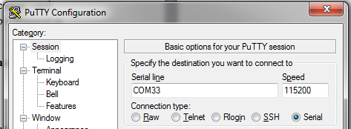

Once logged into STUI using the default user credentials of username:Admin password:Sunhillo, there will be a text-based user interface where a limited set of configuration options similar to what can be found on the Web GUI can be configured and saved here, including the network settings. The SGP product does not support STUI but can be accessed via SSH or local terminal on the SGP GUI and the default login is Username: root Password: sunhillo
For more information on STUI, please refer to SUN2353 - SureLine Core Users Guide.pdf which can be found on your Support Portal account under the Downloads and Uploads area in the Documentation folder.

FAQ 16: Where Do I Get the FTDI Drivers for The Console Cable for Connecting to Sunhillo Products Such as RICI4500s, RICI5000s, Longport Pcms, Ventnors, Brigantines, Margate I M4I, And the Margate II ADS-B Receiver?
Answer:
The latest FTDI drivers will normally install when you connect the cable either from the OS natively or from the internet but in the case this does not occur, here is the link to FTDI’s website for their driver support: https://www.ftdichip.com/Drivers/D2XX.html

FAQ 17: How Do I Know What Operating System And What Software Releases Go Together and How to Upgrade to The Next SureLine Operating System To Use the Latest Software?
Answer:

Every SureLine operating system has release notes in the download area that includes a SureLine operating system upgrade path for the applicable SureLine software release. Each SureLine operating system series has a debut software release and a SureLine operating system upgrade path release often required to migrate up to the next SureLine operating system and software revision as we add features and release new products. SureLine operating systems come with a SureLine software release embedded within it and subsequent SureLine software releases can be installed as they become available in that SureLine operating system series until the next SureLine operating system becomes available and a new series begins. At that time, a new SureLine operating system upgrade path release will become available for download.

Each SureLine OS release applies to a set of board revisions and is listed within the name of the .sop SureLine OS filename which is downloaded from the Support Portal. Board revisions are listed on the About page of SureLine products. Make sure the SureLine OS you install on your SureLine product matches the supported board revision(s) of that SureLine OS package. The SureLine OS release notes include the prerequisite SureLine OS and SureLine software that must be installed prior to upgrading the SureLine OS via the Web GUI Flash OS feature.
Running newer software on an older OS may cause software compatibility issues and is not recommended because the SureLine software may be expecting features within the latest SureLine OS to function properly that aren’t present in the older SureLine OS. It is always recommended to install the latest SureLine OS and SureLine software pair and then upgrade the software once on the latest operating system is installed on your SureLine product.
The following graphic below depicts the SureLine software series from the first software release to the last software release for each SureLine OS revision before a required OS update is required. The OS upgrade path prerequisites are in the OS release notes and it is not always necessary to upgrade incrementally. For example, one can upgrade from OS 4.1.1/SW 6.11.7 directly to OS 5.1.X and skip over the OS 5.0.X revisions.

FAQ 18: How Does Sunhillo’s SureLine Single Sensor Tracker and Multi-Track Fuser Package Work?

FAQ 19: How Do I Know What All the SureLine Dataflow Configuration Parameters Do Since They Are Not All in The SUN2353 - SureLine User’s Guide?
Answer:

When you open a node in the dataflow to set its configuration parameters, you can hover over each parameter and a tooltip appears that gives more information on the purpose or definition of the configuration parameter. If this is still not enough information, please contact support@sunhillo.com with your specific node and configuration parameter in question and we will be happy to help explain how configuration parameter works for your dataflow.
Tooltip Example
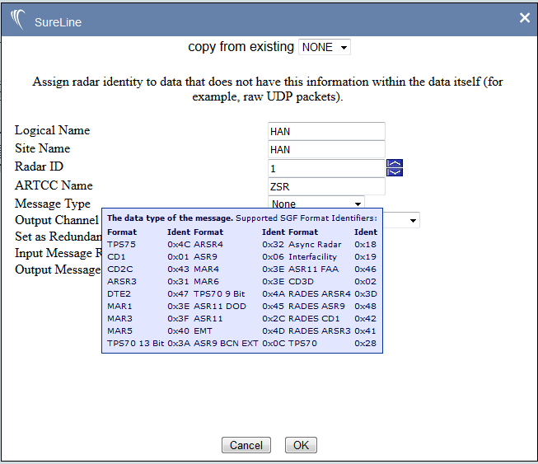

End of Document

